In Constraint Layout, we use guidelines for margins, barriers for moving views, groups for changing attributes at once.

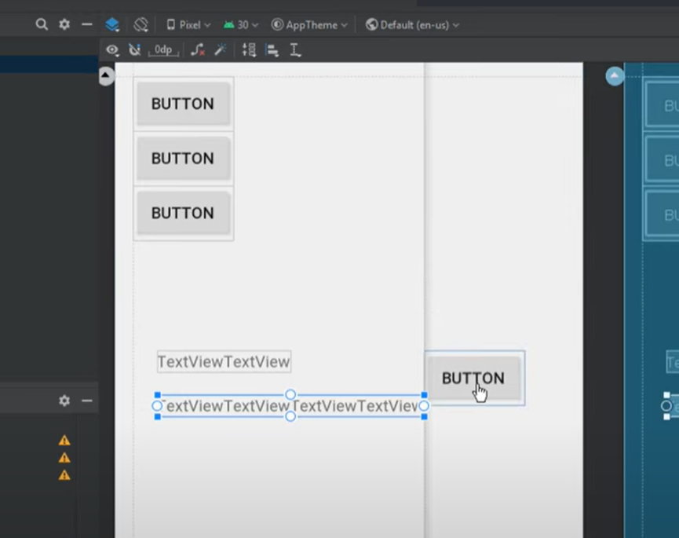

To change icons of colors, we use tint property.

Using view, we can apply lines

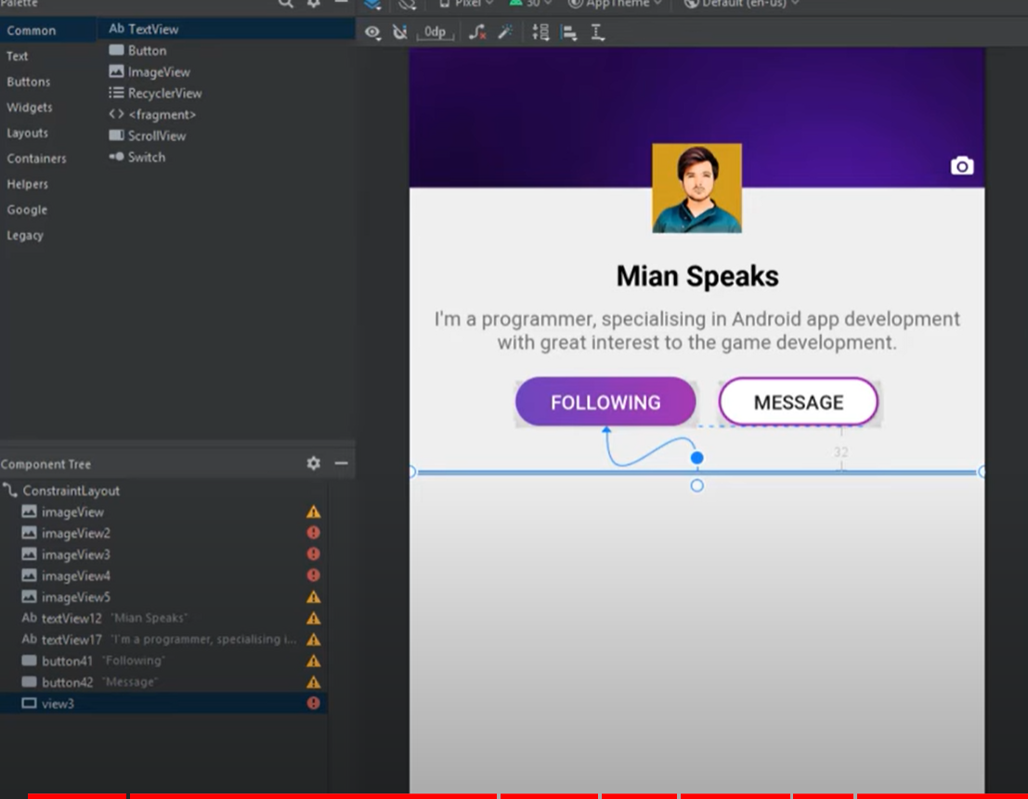

Custom Drawables

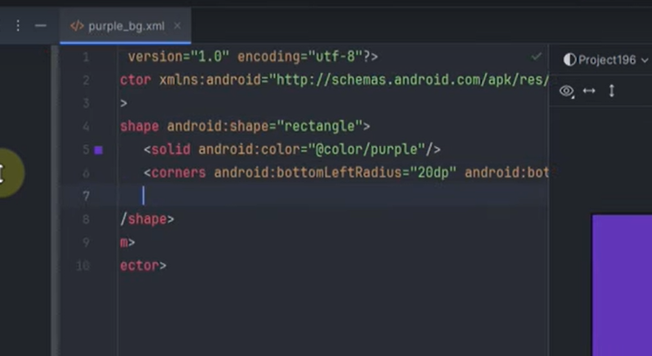

Tab layout:

<https://www.geeksforgeeks.org/android-material-tabs-in-kotlin/>

<https://www.geeksforgeeks.org/kotlin-android-tutorial/?ref=shm>

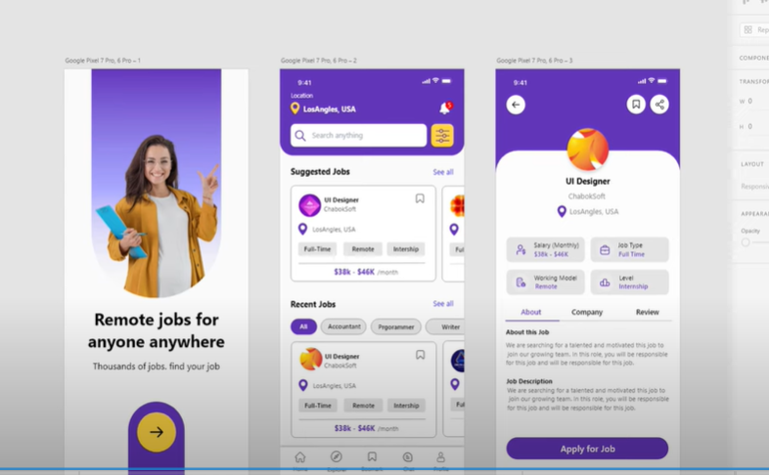

Content Providers  
